Foods with Flair
Mrs. Amundson
amundsonc@barron.k12.wi.us
Room 163/164
Course Description: Foods with Flair is designed for students who have an interest in cooking beyond the basics in the kitchen. Some of the topics that will be addressed include: Foreign foods, regional foods, seasonal influences, garnishing, herbs and seasoning, convenience foods, pasta, pastry, meals on a budget, and careers in food service. This course requires a lot of teamwork and cooperation with your classmates and is an important part of your learning experience.

Course Goals:
- Students will research foods from various cultures.
- Students will evaluate social influences of food choices.
- Students will demonstrate techniques for plating and presentation.
- Students will organize individual and group labs using management techniques.

Grading Procedure: Each student will be graded on daily participation, individual projects and daily assignments. Check Infinite Campus weekly. Be prompt about asking me if you have any questions about specific assignments.

Assignments:
- Assignments will be collected and graded. They are due when assigned.
- Participation points will be given on a daily basis.
- Missed labs will need to be made up at home. Complete the lab form found in Google Classroom
- It is YOUR responsibility to check Google Classroom for assignments
- Each class member is expected to participate in all lab experiences and play an active role in completing the task for the day.

Expectations and Grading:
- Be on time.
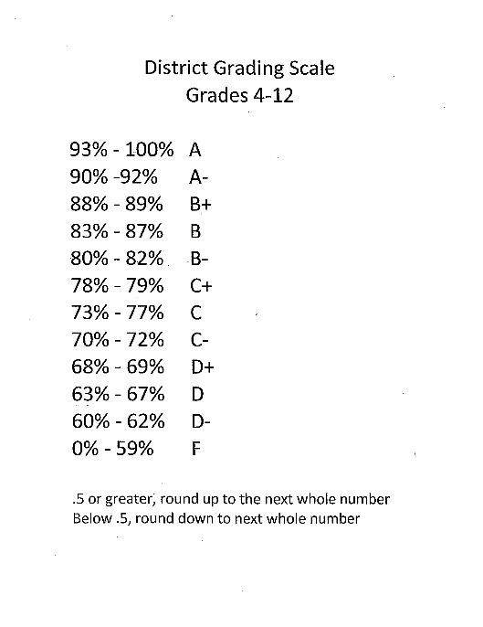
- Be respectful. This means of fellow students and their property, school property and me!
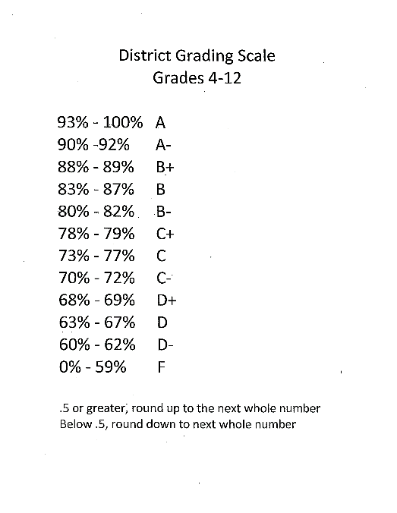
- Always come prepared for class - computer, writing tool, hair tie
- Phones in classroom phone holder
- No outside food or drinks in the classroom.
- Be an active member of your group.
- Have fun!

